

JULY/AUGUST 2016

Megan Dean qualifies for ASA Summer Nationals

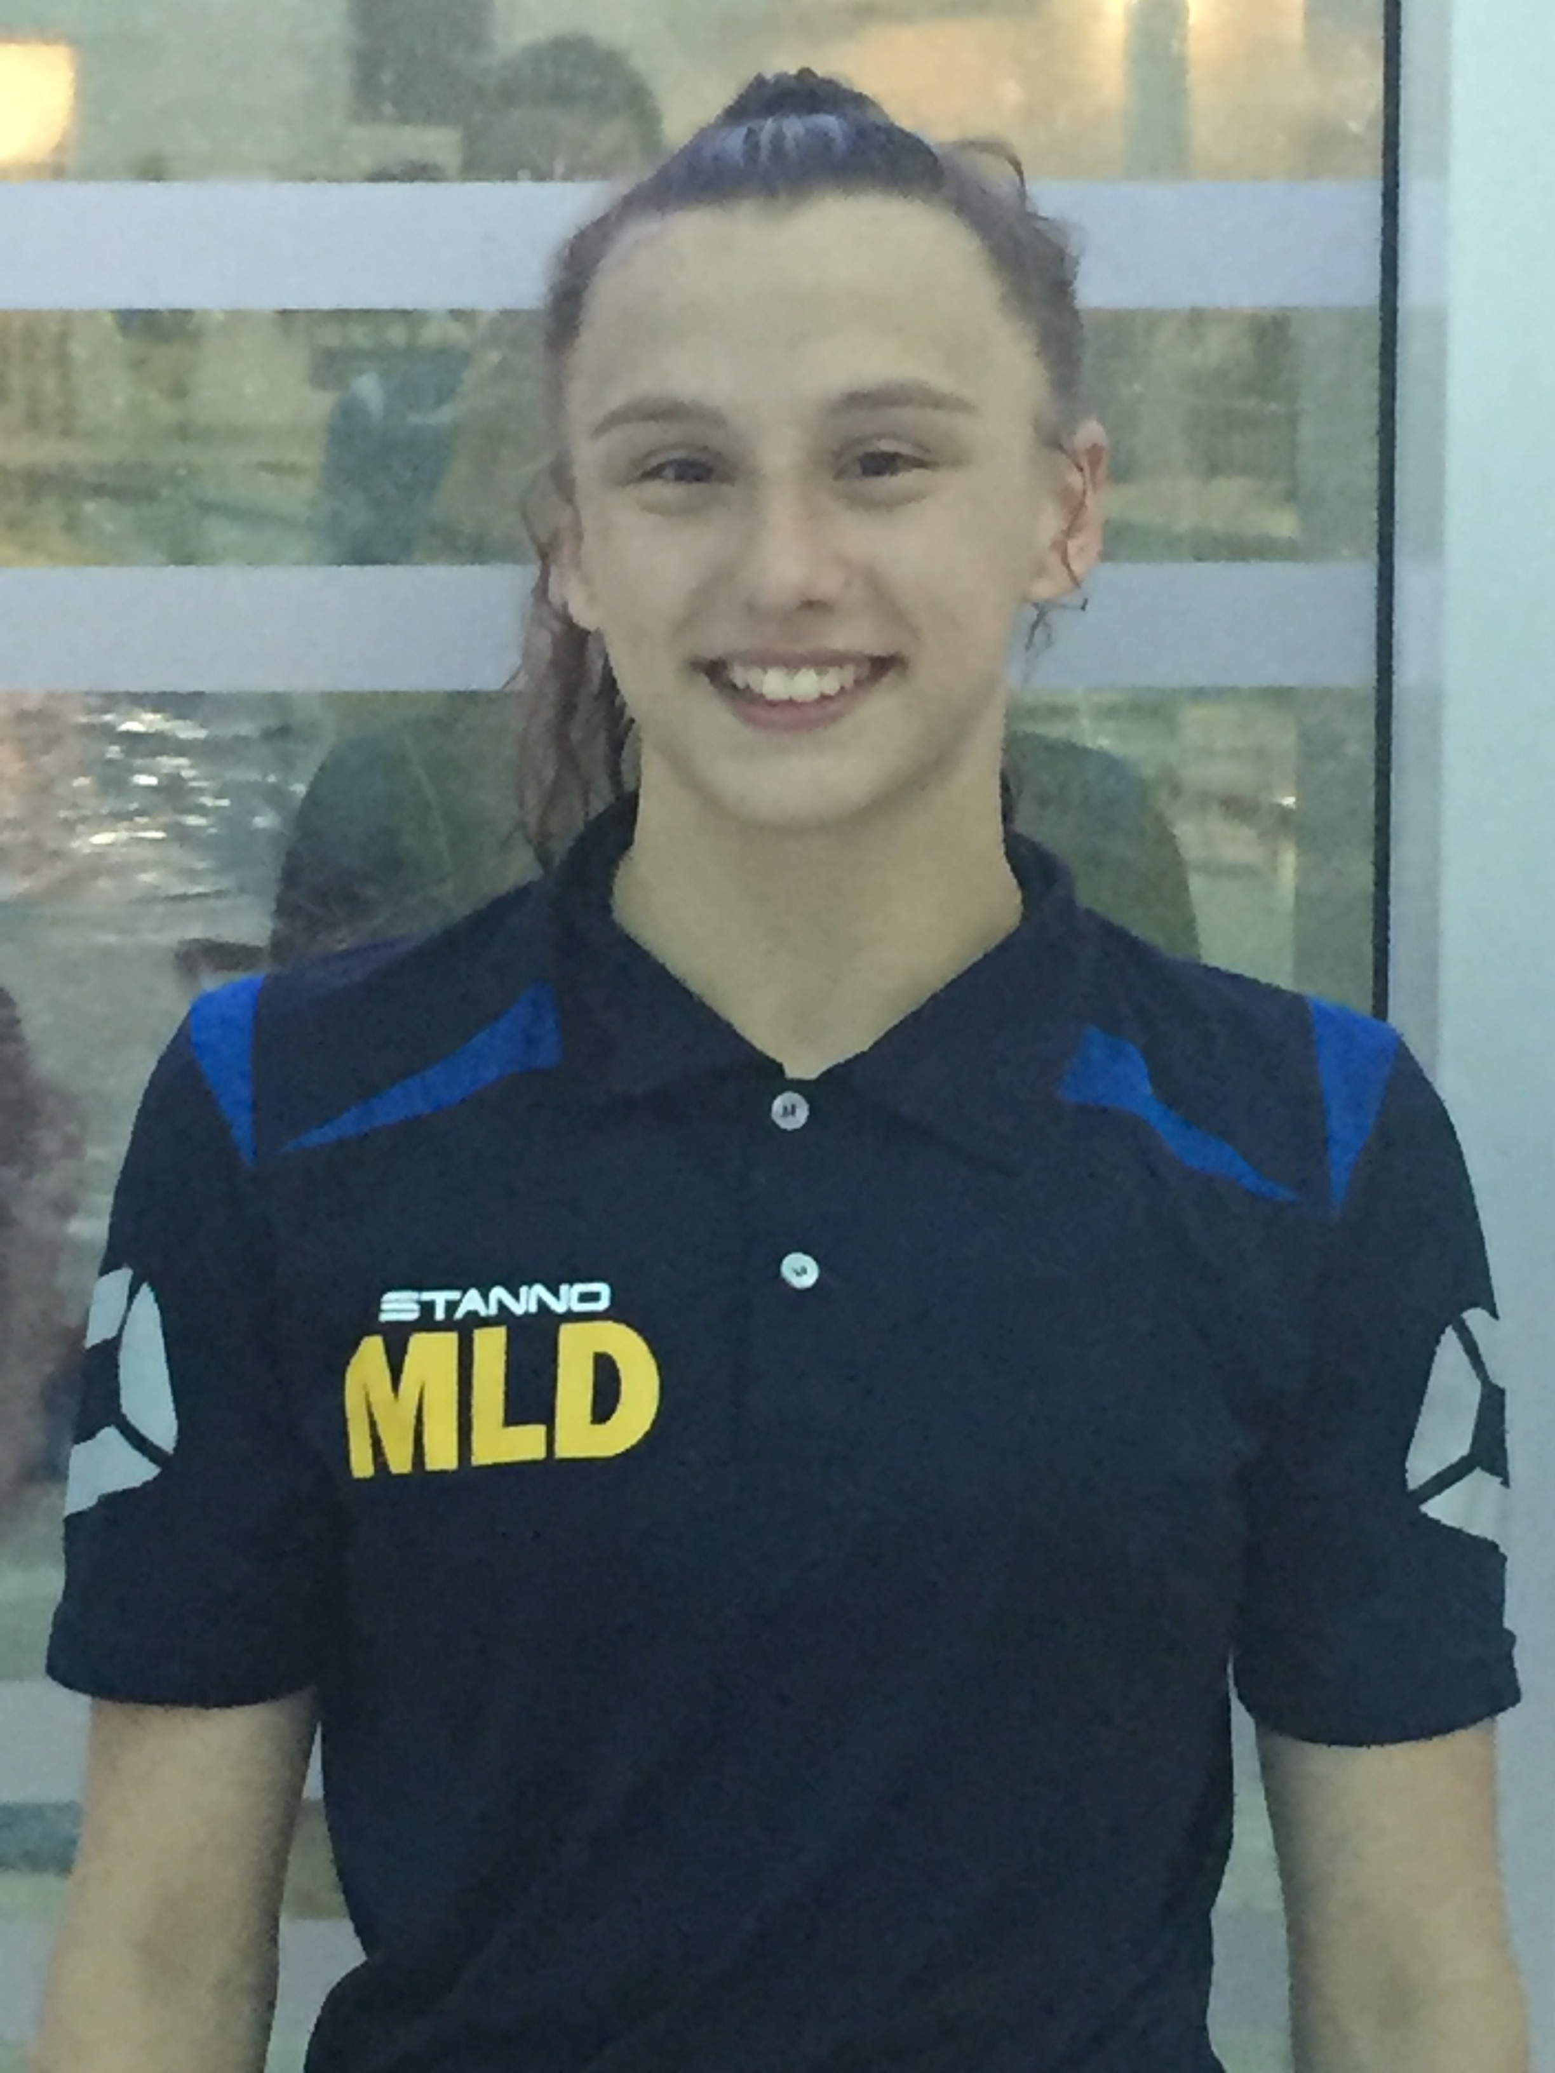
Congratulations to Megan Dean who has qualified for this years ASA Summer Nationals 2016 on the 100m Butterfly.

Megan will compete at Sheffield, Ponds Forge on Tuesday 2nd August 2016 and we wish her the very best of luck.

Holly Lewis qualifies for ASA Open Water Nationals

Congratulations to Holly Lewis who has qualified for the Open Water Nationals on the 3K event to be held at Rother Valley Country Park at the end of July.
Holly was one of the top three swimmers in the region at the recent Midland Open Water Championships.
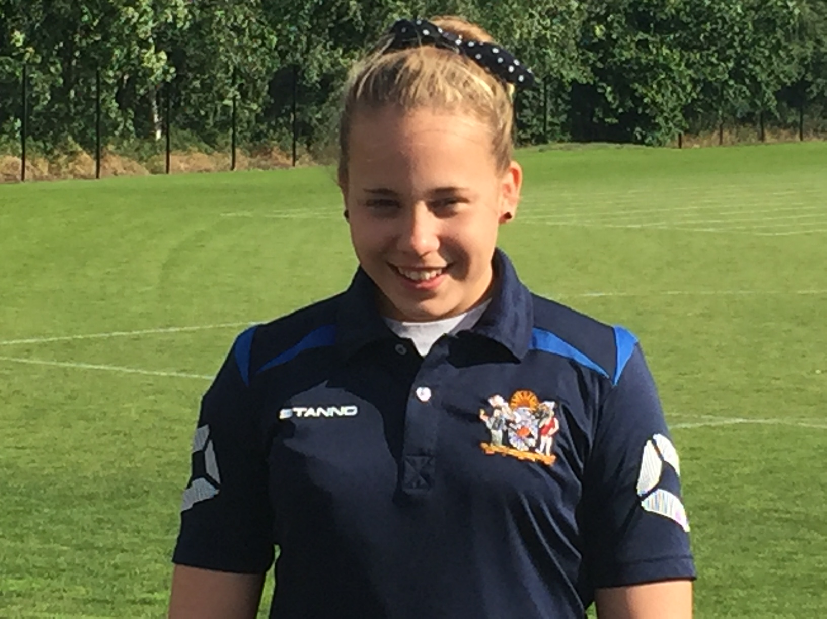

Junior League – 8th place finish

Our junior league team have finished 8th in the first division for the 2016 season. This is an outstanding achievement. In the final round, our team won the gala which is the first time we have won a first division junior gala for four years. Kim is exceptionally proud of the swimmers and the part they have all played in our success this year.

Congratulations to Hayley Wilkes

Congratulations to Bilston coach, Hayley Wilkes, who has given birth to a baby girl. Hayley and Connie-Anne, who weighed in at 8lbs 5oz, are both doing well.

LOTS TO BE PROUD OF – 2015/16 SEASON

- Club remains at 95% plus capacity for the fourth consecutive year
- Club finances remain secure
- Club achieves top half finish in both the Arena League and the Junior League Premier Divisions. Easy to forget that it was not long ago we were competing in the third division of the Arena League and the second division of the Junior League.
- Bilston currently sit top of the Staffordshire Swimming League
- More than 60 swimmers attain County Qualifying Times
- A record number of swimmers have qualified for the West Midland Regional Championships. 23 swimmers in 2016!
- Our boys won the county relay competition in March this year and our club finished in the top three overall.
- Megan Dean qualifies for ASA Summer Nationals and Holly Lewis qualifies for Open Water Nationals
- Medals galore for James Brown at National Para Swimming Championships
- Kiera Langley becomes the clubs first regional gold medallist in nearly two decades.
- Bilston win top club at Stafford Apex meet, Wolverhampton and Haden Hill Meet this year.
- Kim Dean and Mitch Page have both had huge impact this season since being offered official roles within the club
- 13 Bilston swimmers selected to represent our county – a new club record
- Our swimschool goes from strength to strength with lots of investment being put into the training of our staff to ensure we are able to develop the teachers and coaches of the clubs future.

