

Welcome to
Bilston Swimming Club

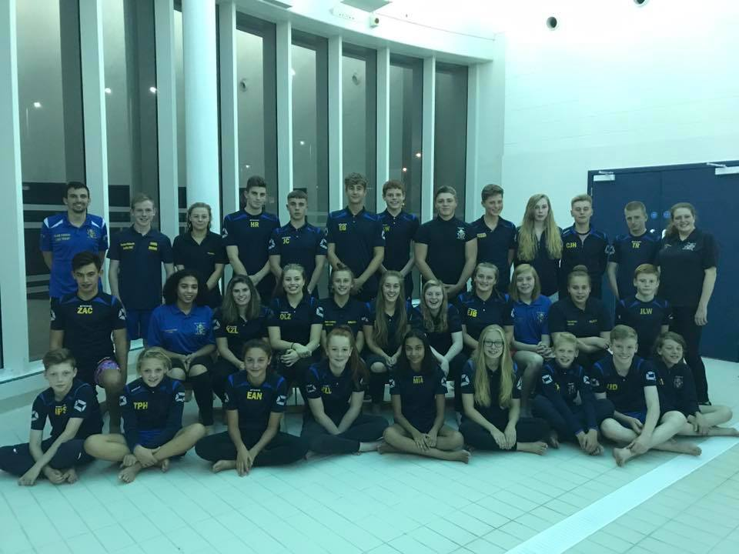
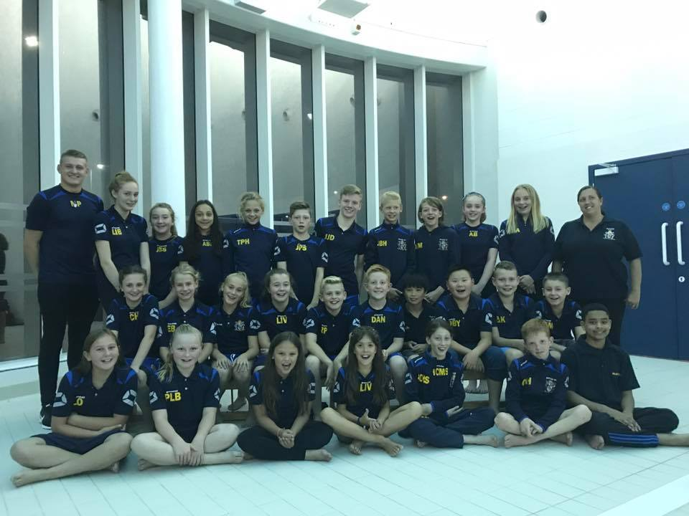

INFORMATION BOOKLET

WELCOME ...

Welcome to Bilston Swimming Club. This booklet is designed to give you all the key information you need to know about our club and how to join.

Bilston Swimming Club is affiliated to the Staffordshire County in the West Midland Region of the Amateur Swimming Association (ASA). All potential new members are entitled to 2 free trials before deciding if they would like to join us. We recommend that potential new members trial on either Tuesday evenings at 7pm or Fridays at 7pm. However, alternative times can be arranged by speaking to one of our coaches.

We cater for children of all abilities from learn to swim to national performance level. After your trial session, one of our coaching or teaching staff will speak to you and advise you as to which one of our squads your child would be best suited to.

Upon deciding to join there is a membership form that needs to be completed. Fees are paid monthly via standing order on the 1st of each month and these monthly fees include club membership and insurance fees for the year. There is a one off joining fee of up to £30.

Our home is the Bert Williams Leisure Centre where we train on all weekdays but we also use a school pool (Willenhall E-Act Academy), Darlaston Leisure Centre for some of our sessions and SWB Academy for our land training.

OUR POOLS
Bert Williams Leisure Centre  Nettlefolds Way  Bilston  WV14 0EF | Willenhall E-Act Academy  Furzebank Way  Willenhall  West Midlands  WV12 4BD | Darlaston Leisure Centre  Victoria Road  Darlaston  WS10 8AP | SWB Academy  Dudley Street  Bilston  West Midlands  WV14 0LN

OUR COACHING AND TEACHING STAFF

HEAD COACH:  Luke Trout  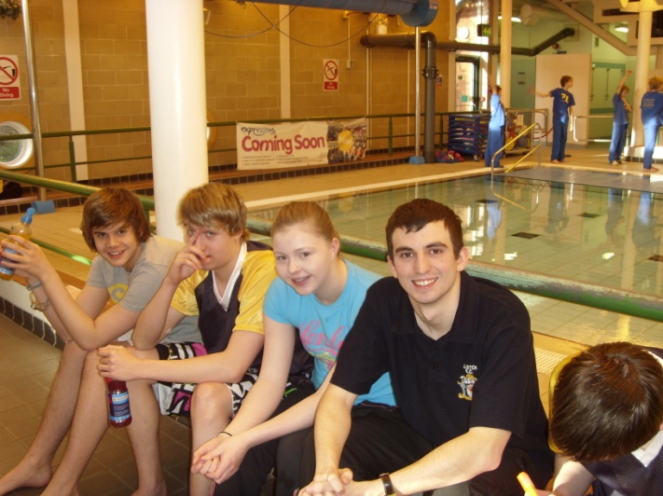  Email: lukerichardtrout@hotmail.co.uk  Telephone: 07772806052 |  | Junior Coach  Kim Dean  
ASSISTANT COACH  Mitchell Page  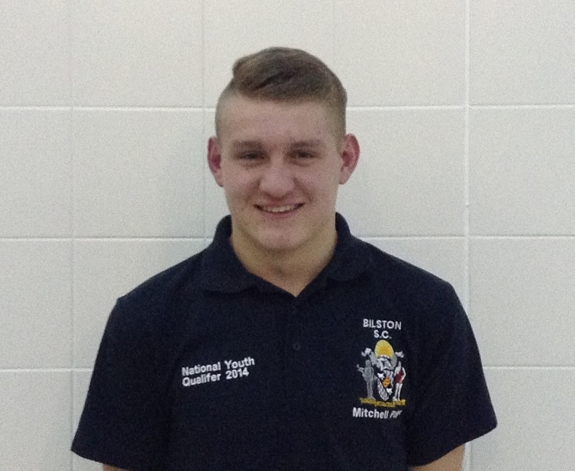 |  | ASSISTANT COACH  Josh Lockley  
COACHING STAFF  Ryan Gutteridge  David Gallagher  Deborah Arnott  Marie Russon  Aaron Crinnian  Eleanor Harley  Robbie Cattell  Charlie Taylor  Chris Peake  Taylor Hodges  Leanne Wilson | TEACHING STAFF  June Hodges(swim school co-ordinator)  Gary Cattell  Neal Daly  Leanne Wilson  Megan Colley  Eleanor Harley  Mark Jacques  Sophie Clayton  Marie Russon  Taylor Hodges |  | TEACHING ASSISTANTS  Leah Arthurs  Callum Hodges  Cieran Pegg  Nathan Cattell  Sian Ellis  Bethany Harris  Katie Bourne  Pavan Johal

OUR COMMITTEE

Our club is run by a committee of approximately 12 members comprising of parents of existing swimmers and long standing supporters of the club. These volunteers meet on the first Wednesday of every month.

Executive committee members are as follows:

Chiarperson: Lisa Pegg
Secretary: Val Thomas
Treasurer: Peter Trout

Our Competitions

Our club competes in the following league competitions each year.

JUNIOR SWIMMING LEAGUE - Ages 9,10,11,12
ARENA SWIMMING LEAGUE - Ages 11,13,15,Op
STAFFORDSHIRE SWIMMING LEAGUE - Ages 11,13,15,Op
MERCIAN SWIMMING LEAGUE - Ages 10,12,14, Op

All team selections are made by the coaching staff and posted on the club noticeboard.

Our Club Kit

Club kit can be ordered from our club website. Click on the club kit tab for further information or speak to the club desk on a Tuesday or Friday evening. Pictures of club kit can be found on the club notice board at Bert Williams Leisure Centre.

CLUB STRUCTURE
There are 5 sections to our club catering from non-swimmers to those swimming at national level.

LEARN TO SWIM
↓
JUNIOR DEVELOPMENT
↓
JUNIOR PERFORMANCE
SENIOR CLUB ←
↓
SENIOR PERFORMANCE
Age guidelines | PROGRAMMED BY | ATTENDANCE | WHEN? | FEES
LEARN TO SWIM  (5yr +) | JUNE HODGES and instructors | 1 per week | TUES/FRI | £40 per 11 week course
JUNIOR DEVELOPMENT  (7 – 12 yrs) | KIM DEAN | Recommended: 3 times per week  Minimum: 2 per week | MON/TUES  THURS/FRI/SUN | £48 per month (up to 5 times per week)  £37 per month (twice)
JUNIOR PERFORMANCE 1  (9-11 years) | KIM DEAN | 3+ times per week | MON/WED/  THURS/FRI  SUN | £55 per month
JUNIOR PERFORMANCE 2 | MITCH PAGE | 4+ times per week | MON/TUES/THURS  FRI/SAT/SUN  (plus land training) | £55 per month
SENIOR CLUB (13+) | LUKE TROUT | Twice per week | TUES/FRI/SUN | £37 per month
SENIOR PERFORMANCE  (11/12 yrs +) | LUKE TROUT | Recommended: 5+ times per week  Minimum: 3 times per week | All week days plus two weekday mornings plus land training on Tues 6 – 6.45, Thurs 7-7.20pm Fri 6 – 6.45 & 9 – 9.20 | £58 per month

Progression from one squad to the next is at the Coach’s discretion.

SQUAD EXPLANATIONS

LEARN TO SWIM → 5 years +

Our swimschool runs on Tuesday and Friday evenings (7 – 7.40pm, 7.40pm – 8.20pm and 8.20 – 9pm) in the learner pool. Unlike the rest of the club, fees are paid by cheque or cash via 11 week courses. June Hodges, our swimschool coordinator, is in charge of this section of the club and is always happy to answer any questions.

JUNIOR DEVELOPMENT → 7 – 12 years old

This section of the club is for those who are interested in competitive swimming and are therefore able to commit more time to the club. Swimmers in this section are entitled to swim up to 5 times per week and have access to more than 7 hours of pool space. The aim is develop all 4 strokes as well as to teach proficient diving and all 7 competitive turns. Some swimmers in this section will be expected to gain County qualifying times.

It is recommended that swimmers train at least 3 times per week but there is an option to train 2 times per week.

Training Times

DAY | TIME | WHERE
Monday | 7 – 8.30pm | Bilston
Tuesday | 7 – 7.45pm  7.45 – 9pm | Bilston
Thursday | 7 – 8.30pm | Willenhall School
Friday | 7 – 8 or 8 – 9pm | Bilston
Sunday | 12noon – 1.15pm | Bilston

Fees (payable on 1st of each month by standing order)

- £48 per month (recommended) – entitled to 5 sessions per week 2. £37 per month (twice per week)

JUNIOR PERFORMANCE → Selected 10 – 12 years

Those swimmers in our junior development squad that have good long term potential and have qualified for multiple county events may be invited to join the junior performance squad. Please note that movement from the development to performance squad is at the discretion of the coach. Swimmers must train a minimum of three times per week in Junior Performance One and a minimum of four times per week in Junior Performance Two. Swimmers in this squad are entitled to a free log book whereby swimmers should record all of their times from competitions and keep a record of their attendance. The coach will request to see log books three times per year and set targets as to that swimmers future development

Training Times

DAY | JUNIOR PERFORMANCE 1 | JUNIOR PERFORMANCE 2
MONDAY | 7 – 8.30PM  BILSTON | 7 – 9PM  WILLENHALL
TUESDAY |  | 6 – 6.45pm land training @ SWB  7 – 9 pm BILSTON
WEDNESDAY | 7 – 9PM  BILSTON
THURSDAY | 7 – 8.30pm  WILLENHALL | 7.00 – 7.20pm land training poolside @ BILSTON  7.30 – 9PM  BILSTON
FRIDAY | 7 – 9pm | 6 – 6.45pm land training @ SWB  7 – 9PM BILSTON  9 – 9.20pm flexibility
SATURDAY |  | 9 –11AM  BILSTON
SUNDAY | 1.15 – 2.30pm BILSTON | 1.15. – 2.30PM  BILSTON

Fees (payable on 1st of each month via standing order)

1.£55 per month – unlimited sessions + £6 per month for land training

SENIOR CLUB → 13 years +

This is for swimmers who are unable to commit to 3 or more sessions per week but still want to keep fit and be considered for team selection. Swimmers in this squad are entitled to train twice per week in the sessions outlined below.

Training Times

DAY | TIME | WHERE
Tuesday | 7 - 9pm | BILSTON
Friday | 7 – 9pm | BILSTON
Sunday | 1.15 – 2.30pm | BILSTON

Fees(payable on 1st of each month via standing order)
1.£37 per month – 2 sessions per week

SENIOR PERFORMANCE → 12 years +
This is the club’s top squad for our best athletes. Swimmers in this squad are expected to have multiple county times and be aiming for Midland and National times. It is recommended that swimmers in this squad train 5 times per week. Swimmers in this squad are entitled to a free log book whereby swimmers should record all of their times from competitions and keep a record of their attendance. The coach will request to see log books three times per year and set targets as to that swimmers future development.

Swimmers in this section will also have the opportunity to do land training where the focus will be core stability training.
Training Times

DAY | TIME | WHERE
MONDAY | 5.55am – 7.25am  7 – 9 pm | Darlaston  Willenhall
TUESDAY | 7 – 9 pm  6 -6.45 land training | Bilston  SWB
WEDNESDAY | 7 – 9pm | Bilston
THURSDAY | 5.55 – 7.25am  7 – 7.20pm land training  7.30 – 9pm | Darlaston  Bilston  Bilston
FRIDAY | 7 – 9pm  9 – 9.20pm flexibility  6 – 6.45pm land training | Bilston  Bilston  SWB
SATURDAY | 9am - 11am | Bilston
SUNDAY | 1.15 – 2.30pm | Bilston

Fees (payable on 1st of each month via standing order)

1.£58 per month – unlimited sessions + £6 per month for land training

Additional land based work now runs on Thursdays 7 – 7.20pm on poolside and on Fridays 9 – 9.20pm on poolside.

Communication:

Club Noticeboard

Please remember to check our notice board at the Bert Williams Leisure Centre every time you swim as all the latest information will be here. Team selections for galas will normally be posted on this board 10 days before the gala takes place.

Club Website

Once a new member has been registered with the ASA, they will have an account created on the club’s website (www.bilstonsc.co.uk). The username is their ASA number and their initial password is sw1mm1ng. When you logon to the site for the first time, you will be prompted to change the password. The website noticeboard is regularly updated and it should be checked on a regular basis
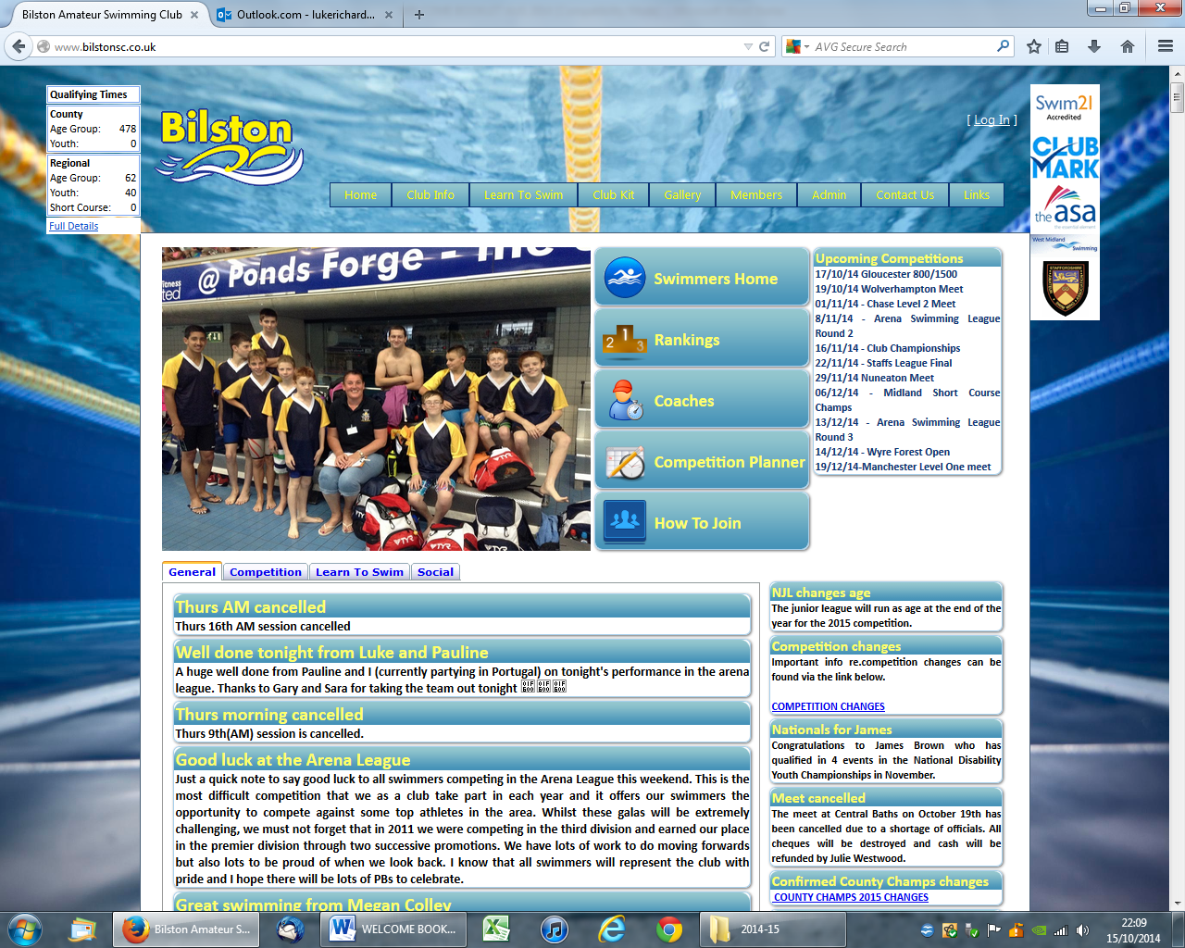

Club Phone

Whenever a session is cancelled at short notice, the club will endeavour to contact you via text to let you know but you should always check the website if you are not sure.

Facebook

Join our Bilston SC supporters page

Club desk

Our club desk operates on Tuesday and Friday evenings and you can ask questions you may have.

Email
The club will email members about upcoming open meets and session changes/cancellations. Please ensure you pass your email address to the club desk on a Tuesday or Friday evening at Bilston.

