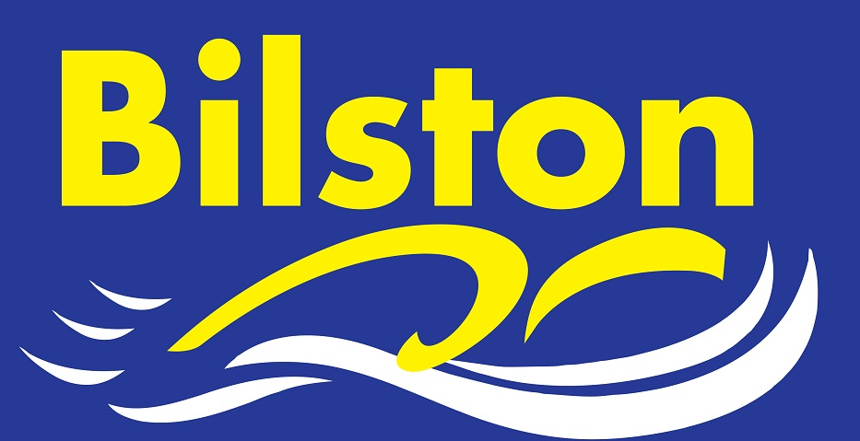
NO LAND TRAINING @ SWB ON:
TUES 20th DEC
FRI 23rd DEC
TUES 27th DEC
FRI 30th DEC

WILLENHALL CLOSED FROM SUN 20TH – TUES 3RD JAN
CHRISTMAS TRAINING 2016
 | COMMUNITY | JUNIOR DEVELOPMENT | JUNIOR PERFORMANCE 1 | JUNIOR PERFORMANCE 2 | SENIOR PERFORMANCE
MON 19TH |  | 7 – 8.30pm | 7 – 8.30pm | 9-11am @ BW tbc | 9-11am @ BW tbc
TUES 20TH | 7 – 7.45 | 7-7.45 & 7.45 – 9 |  | 7 – 9 | 7 – 9pm
WED 21ST |  |  | 7 – 9pm |  | 7 – 9pm
THURS 22ND |  |  |  | 7.30 – 9pm (and land work) | 7.30 – 9pm (and land work)
FRI 23RD | 7 – 7.45 | 7 – 8 & 8 – 9pm | 7 – 9pm | 7 – 9pm | 7 – 9pm
SAT 24TH
SUN 25TH
MON 26TH
TUES 27TH | 7 – 7.45 | 7-7.45 & 7.45 – 9 |  | 7 – 9 | 7 – 9pm
WED 28TH |  |  | 7 – 9pm |  | 7 – 9pm
THURS 29TH |  |  |  | 7.30 – 9pm (and land work) | 7.30 – 9pm (and land work)
FRI 30TH | 7 – 7.45 | 7 – 8 & 8 – 9pm | 7 – 9pm | 7 – 9pm | 7 – 9pm
SAT 31ST |  |  |  | 9 – 11am | 9 -11am
SUN 1ST
MON 2nd |  | 7 – 8.30pm | 7 – 8.30pm | 9-11am @BW tbc | 9-11am @BW tbc

All training at Bert Williams. Merry Christmas everyone!!!

